Aditi Mallavarapu

CS 412 Homework 1

Problem 1 a)

%% Classify the MNIST digits using a one nearest neighbour classifier and Euclidean distance

%% This file is modified from pmtk3.googlecode.com

load('mnistData');

% set training & testing

errorRate= [];

errorndx = 1;

varlimit = [100, 200,500,1000,2000,5000,10000]

for entry = varlimit

trainndx = 1:entry;

testndx = 1:10000;

ntrain = length(trainndx);

ntest = length(testndx);

Xtrain = double(reshape(mnist.train_images(:,:,trainndx),28*28,ntrain)');

Xtest = double(reshape(mnist.test_images(:,:,testndx),28*28,ntest)');

ytrain = (mnist.train_labels(trainndx));

ytest = (mnist.test_labels(testndx));

% Precompute sum of squares term for speed

XtrainSOS = sum(Xtrain.^2,2);

XtestSOS = sum(Xtest.^2,2);

% fully solution takes too much memory so we will classify in batches

% nbatches must be an even divisor of ntest, increase if you run out of memory

if ntest > 2000

nbatches = 50;

else

nbatches = 5;

end

batches = mat2cell(1:ntest,1,(ntest/nbatches)*ones(1,nbatches));

ypred = zeros(ntest,1);

closestndx = [];

% Classify

for i=1:nbatches

dst = sqDistance(Xtest(batches{i},:),Xtrain,XtestSOS(batches{i},:),XtrainSOS);

[junk,closest] = min(dst,[],2);

ypred(batches{i}) = ytrain(closest);

closestndx(batches{i}) = closest;

end

% Report

errorRate(errorndx) = mean(ypred ~= ytest);

fprintf('Error Rate: %.2f%%\n',100*errorRate(errorndx));

errorndx = errorndx + 1;

imagesamp= [];

%find the images that were misclassified

imagesamp = (ypred~=ytest);

for i = 1 : length(imagesamp)

if (imagesamp(i) == 1)

index = i;

figure,

subplot(2,1,1)

imshow(mnist.test_images(:,:,index)) % the misclassified image

title(entry)

subplot(2,1,2)

imshow(mnist.train_images(:,:,closestndx(index))) % the nearest neighbor image

title(entry)

break;

endif

end

end

%%% Plot example

% line plot example random data

figure, plot(errorRate)

ylabel('accuracy')

Misclassified Images plots (Upper image) and their nearest neighbor (lower image)

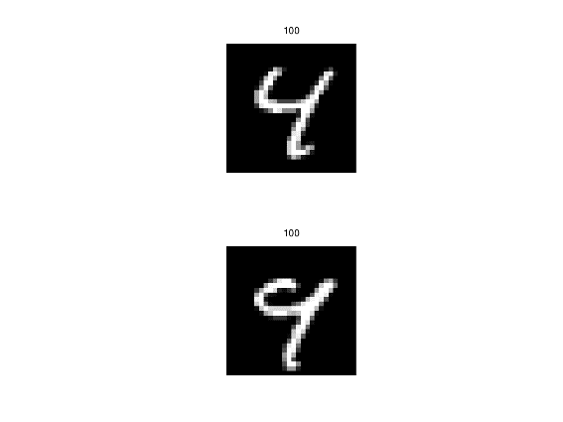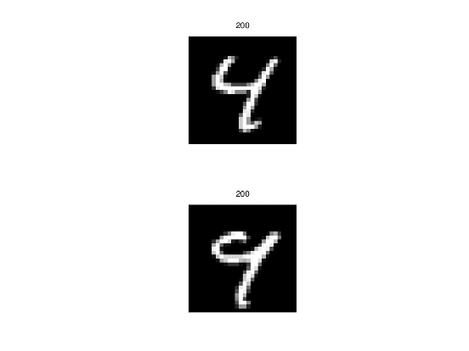

Training Size 100 Training Size 200

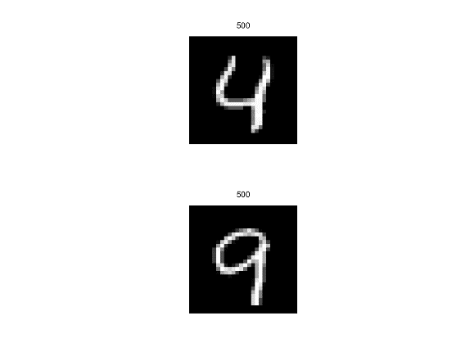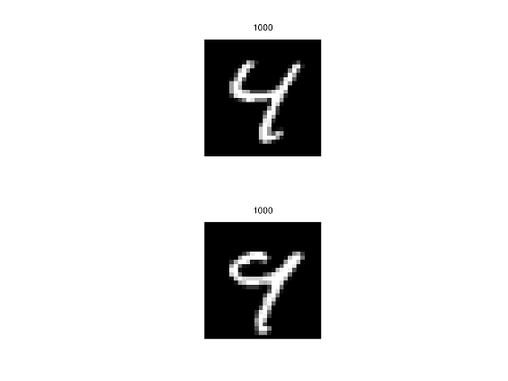

Training Size 500 Training Size 1000

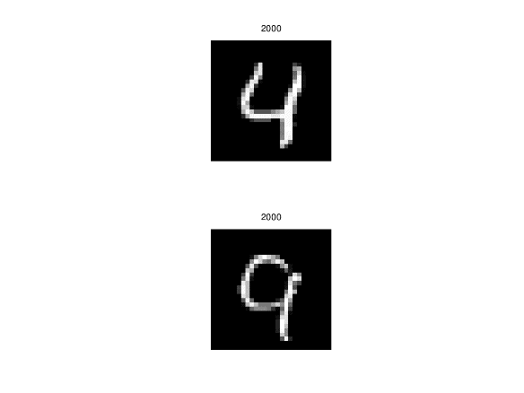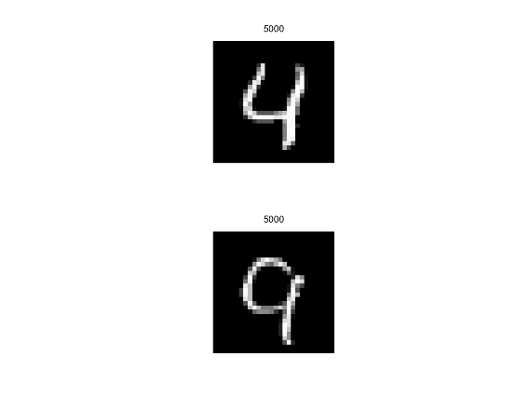

Training Size 2000 Training Size 5000

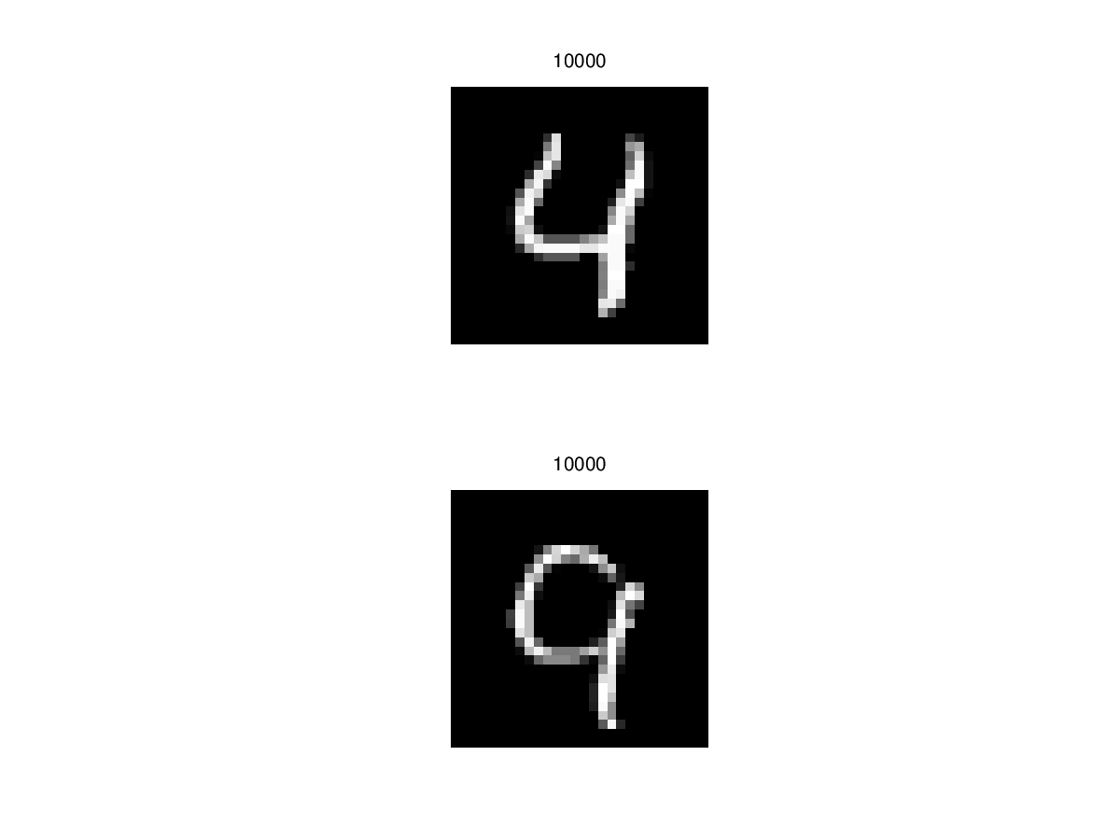

Training Size 10000

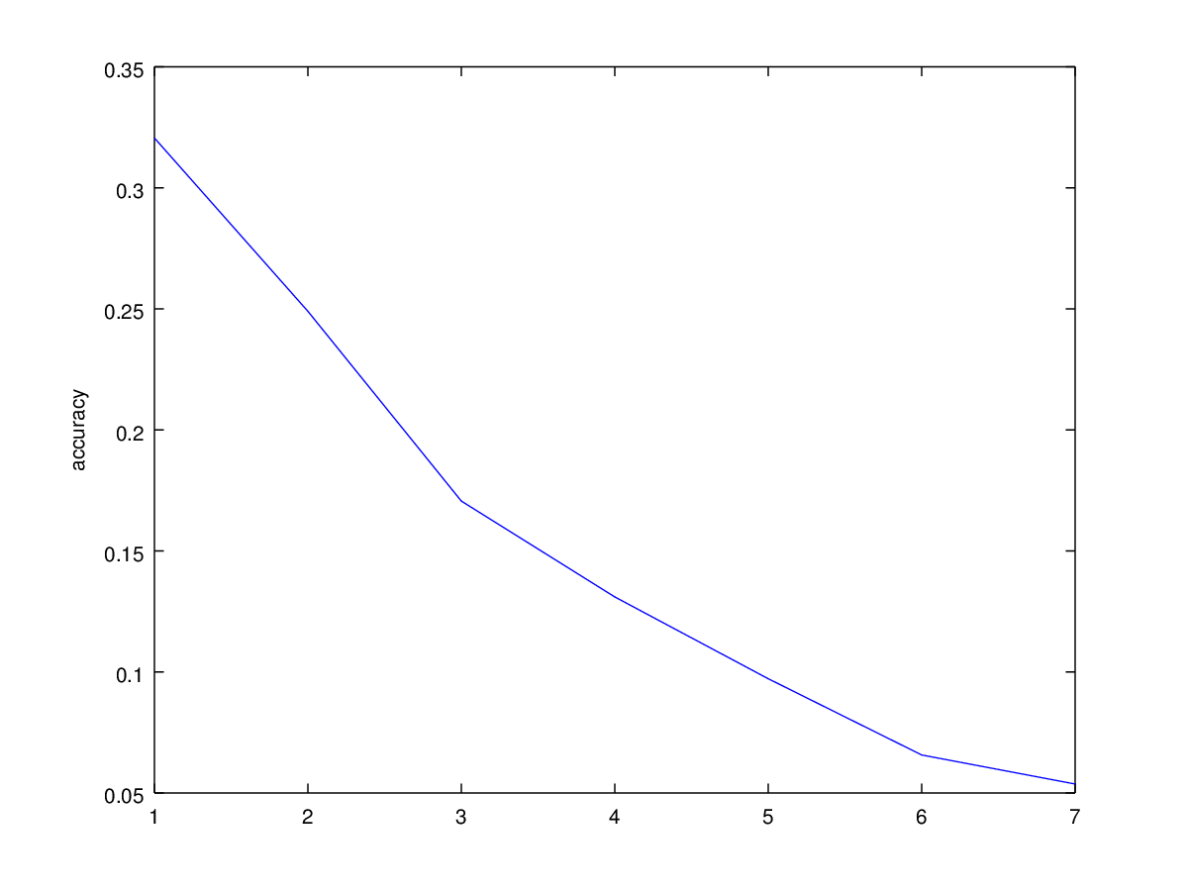

Error Plot